Aspen Chalets & Caviar WordPress Guide

Contents

Login 3

New Post: Titles & Categories 4

New Post (Cont.): Featured Image 4

New Post (Cont.): Image Slideshow 6

New Post (Cont.): Post Details. 8

Edit a Post: 11

Delete a Post: 12

# Login

1. Go to <http://dev-aspen-chalets-and-caviar.pantheonsite.io/wp-login.php>

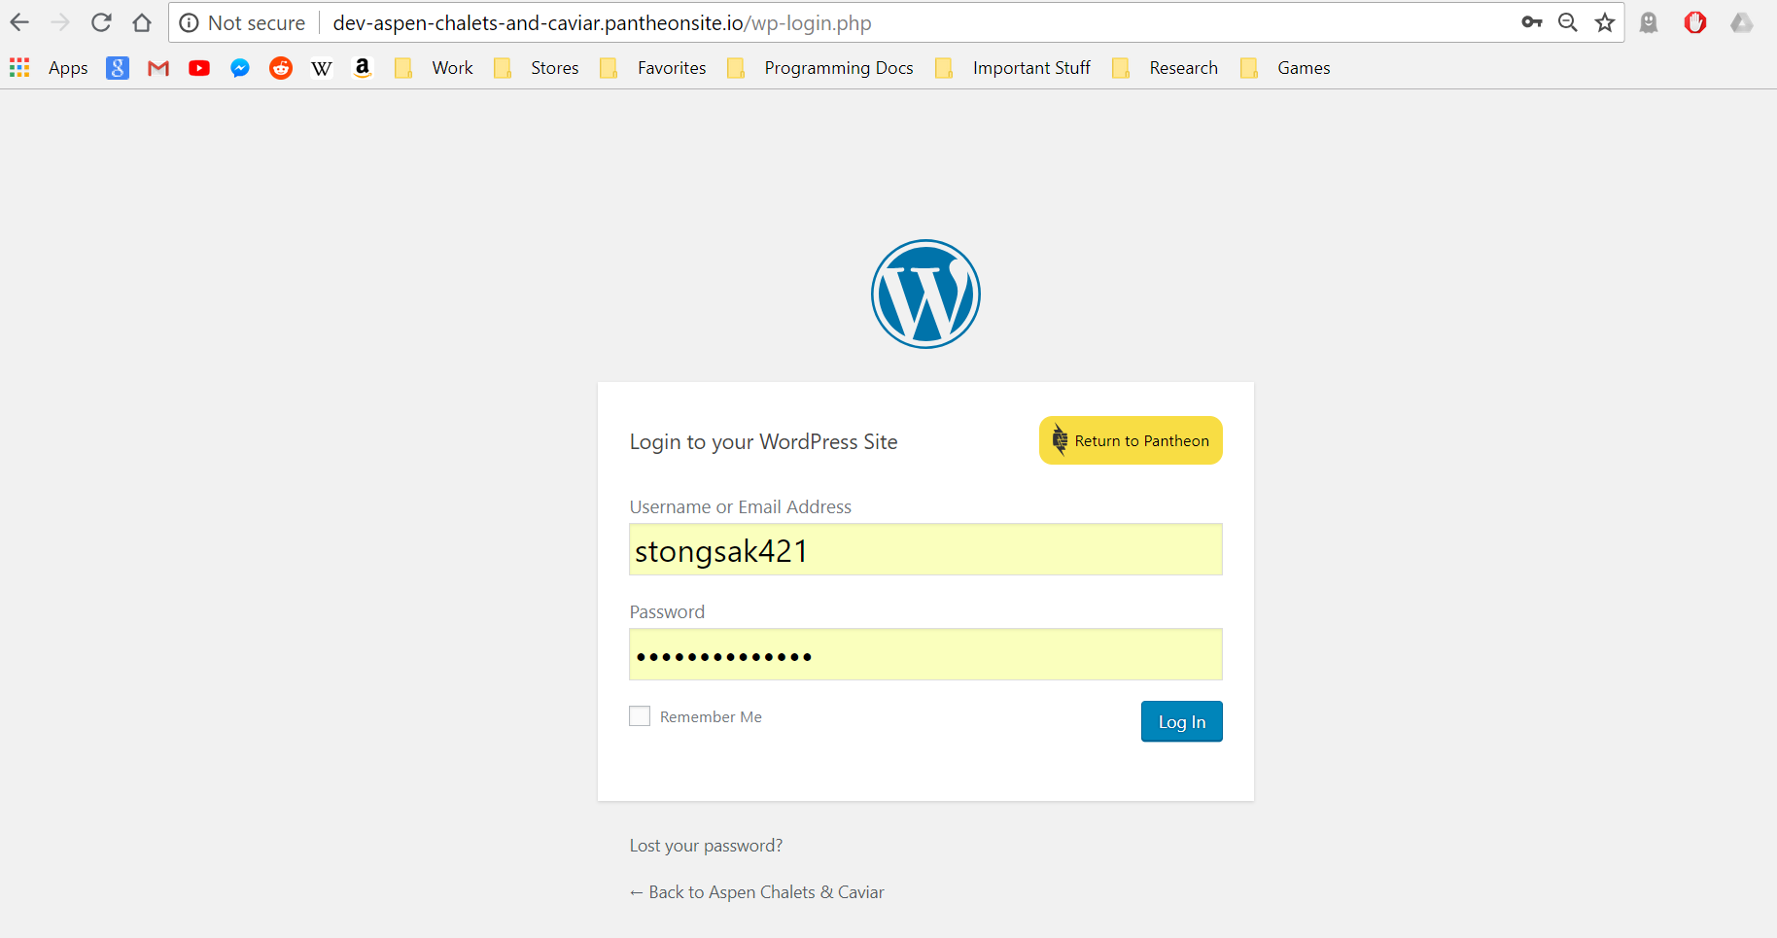

1. Input your Username / Email Address & Password
2. Click “Log In”
3. You’re taken to the Dashboard of Aspen Chalet & Caviar

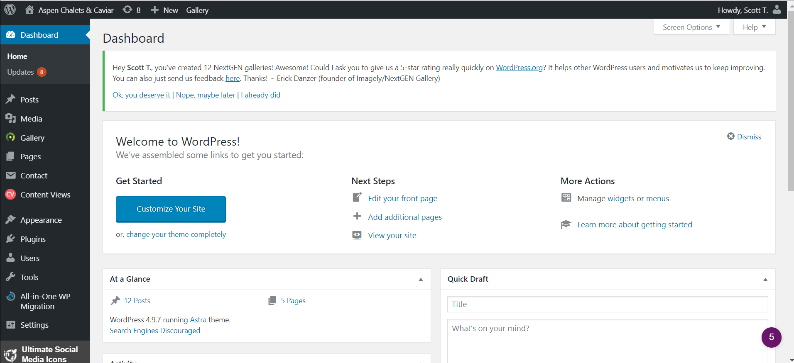

# New Post: Titles & Categories

1. Hover over “Post” and a drop down menu will appear with “Add new”. Click on it.

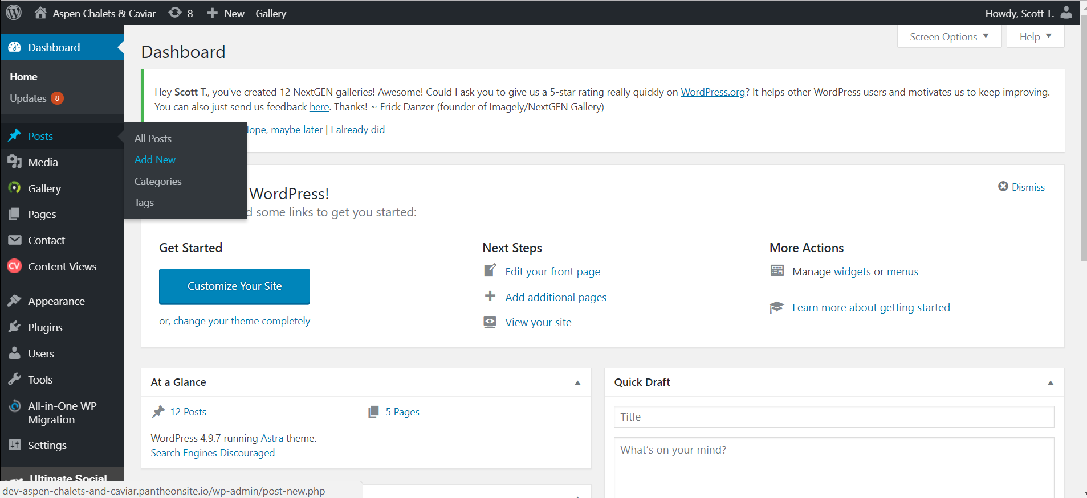

1. Enter the Chalet’s Name and method of sales. (Sold / Rental)
2. Check box the appropriate category for the Chalet (For Sale / Rental)

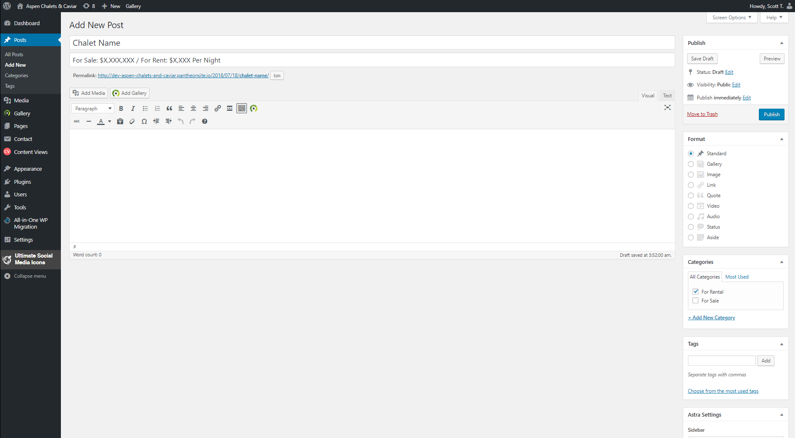

# New Post (Cont.): Featured Image

1. To Add the Featured Image (Thumbnail image for the Chalet), click on “Add Media”

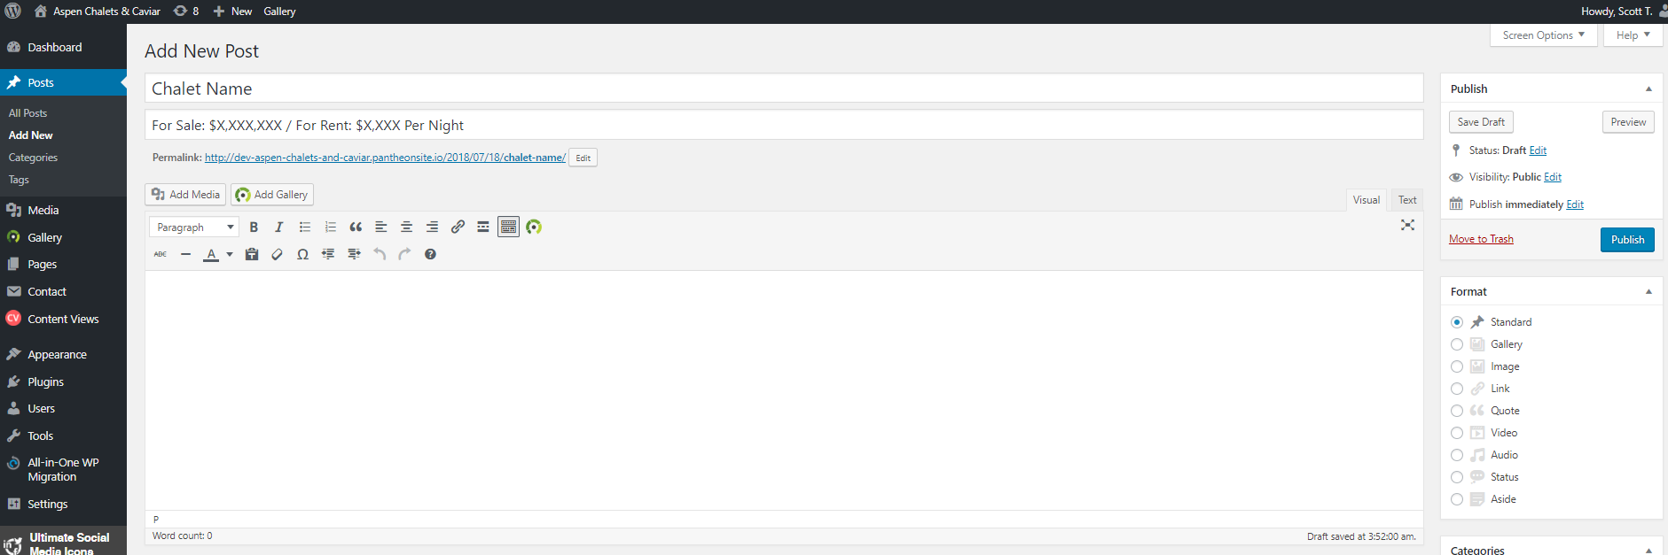

1. Click on “Featured Image” and then click on “Upload Files”
2. Click on “Select Files”

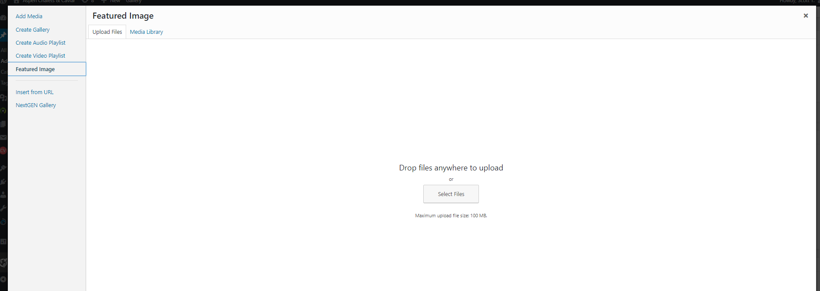

1. Browse your Computer’s Directory and Open 1 picture to be the Thumbnail for the Chalet

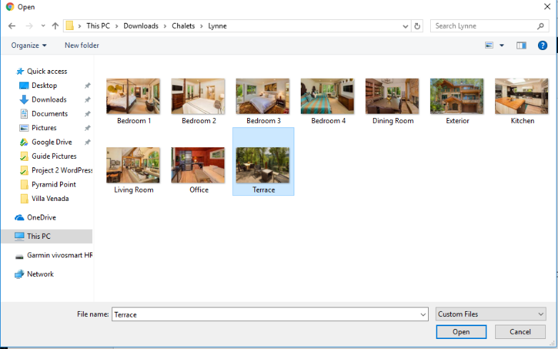

1. Your newly uploaded picture will be on the top left of the current screen, click “Set featured image” to finalize the selection.

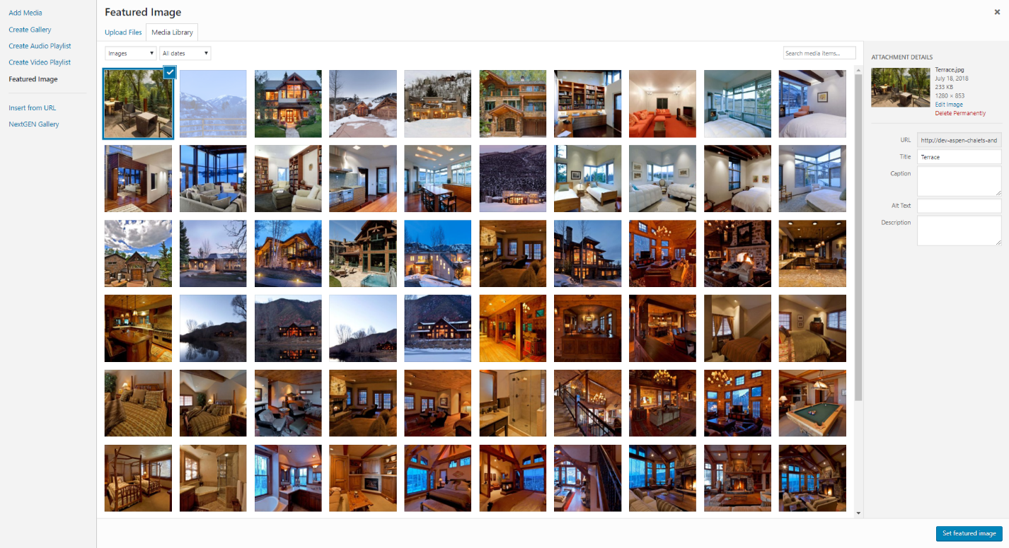

1. When the picture is selected the Thumbnail will appear at the bottom of the New Post page.

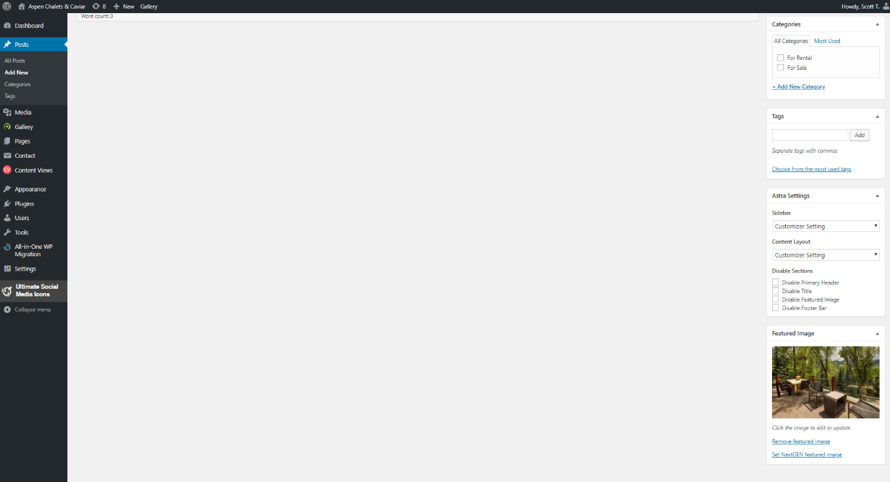

# New Post (Cont.): Image Slideshow

1. Click on “Add Gallery”



1. Click on Upload Images.

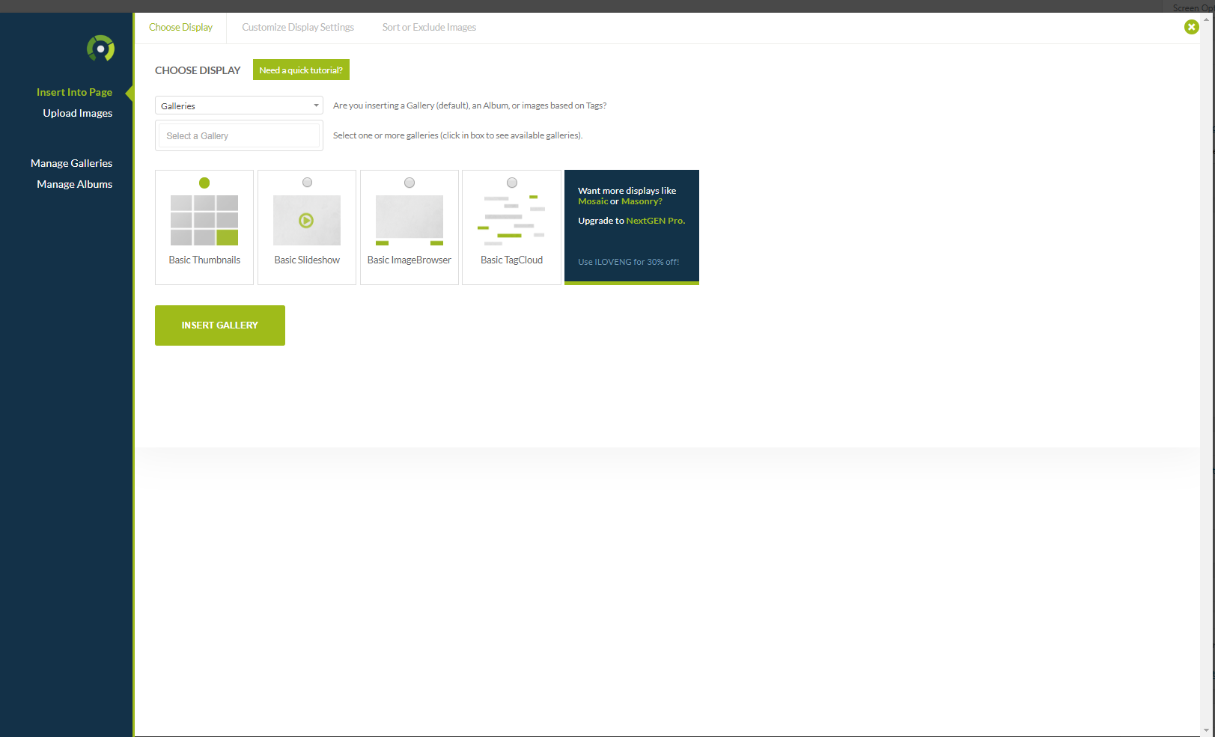

1. Fill in Gallery Title with Chalet’s Name and click on “Add Files”

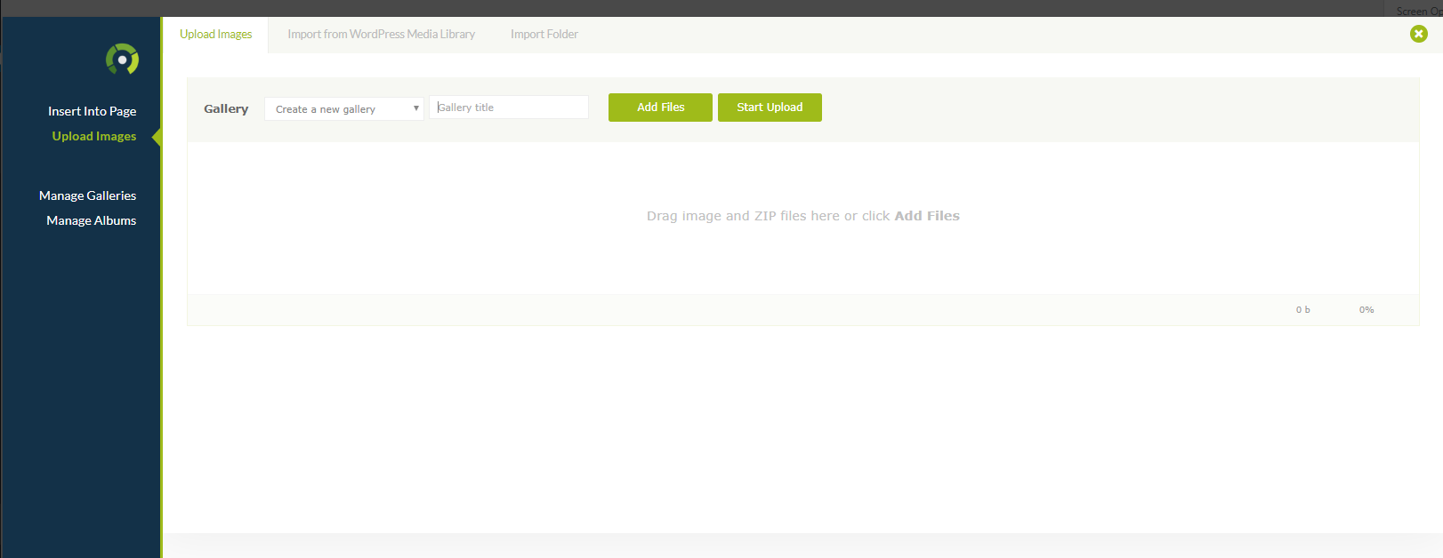

1. Upload all the pictures of the Chalet (exterior, interior, rooms, etc)

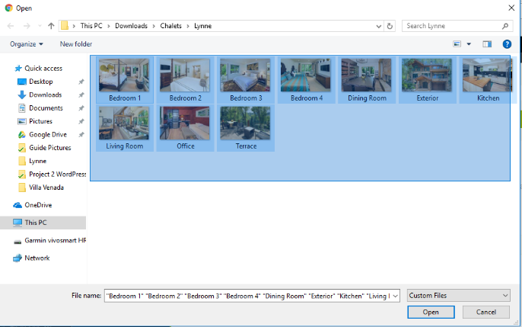

1. Click on “Start Upload” to start uploading the pictures.

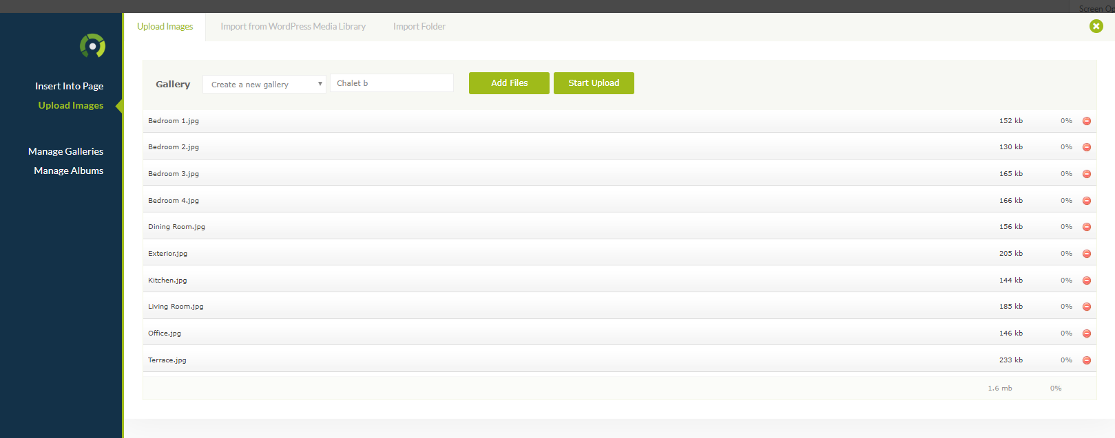

1. Go back to the first page by clicking “Insert Into Page”

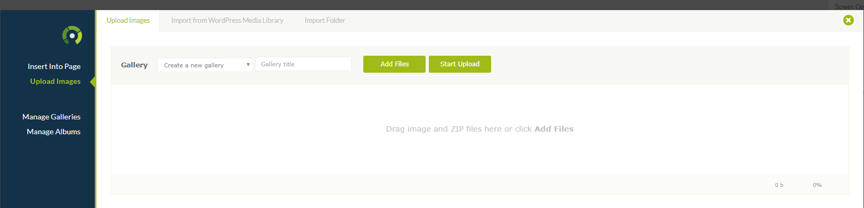

1. Select Chalet Gallery Title you created earlier.

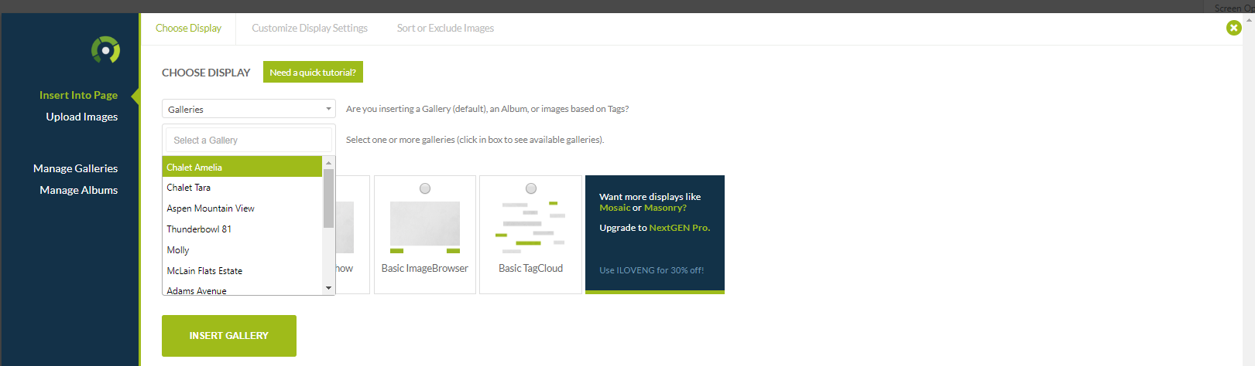

1. Select “Basic ImageBrowser” and Click on “Insert Gallery” to finish.

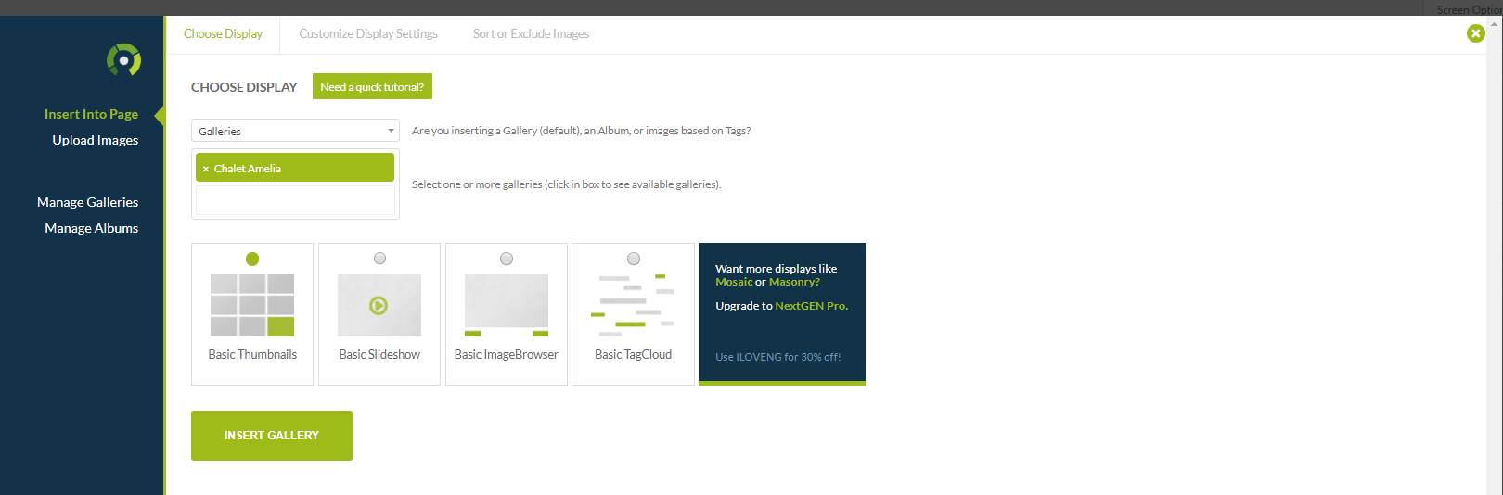

1. Now your Image Gallery as an ImageBrowser has been insert into the body of your post.

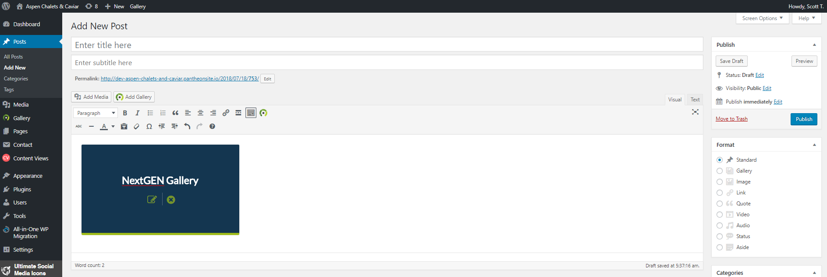

# New Post (Cont.): Post Details.

1. Underneath the NextGEN Gallery insert you can type the main details of the Chalet.

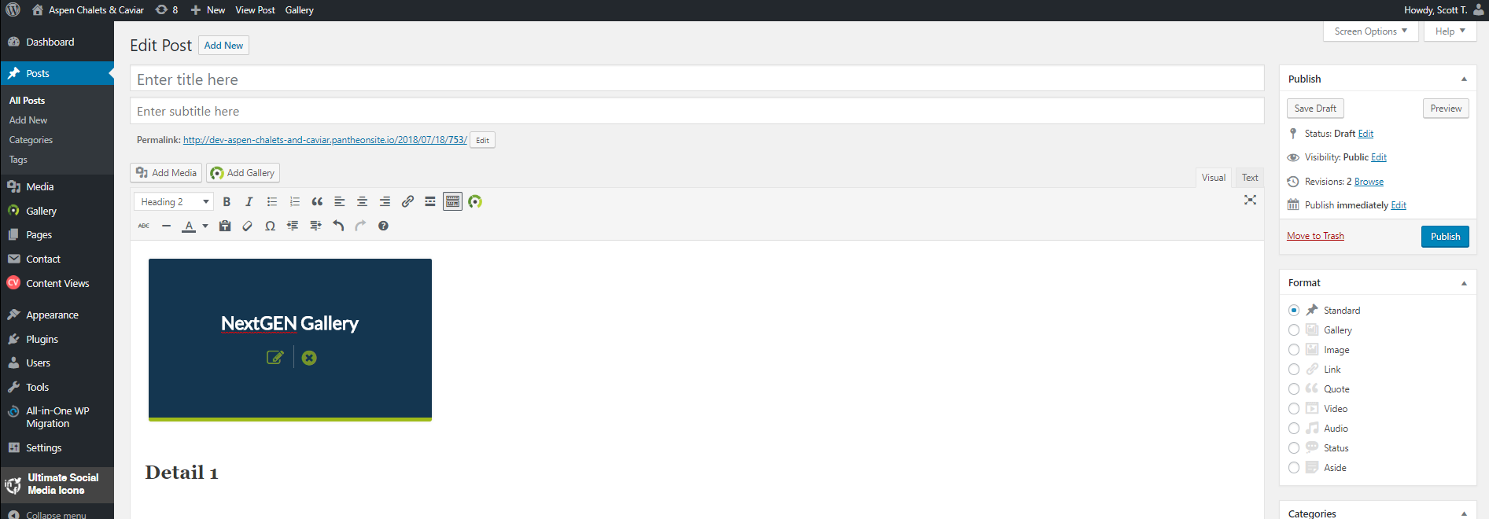

1. First, select “Heading 3” for the style of the major details.



1. Type out your first detail, i.e.: 5 Bedrooms

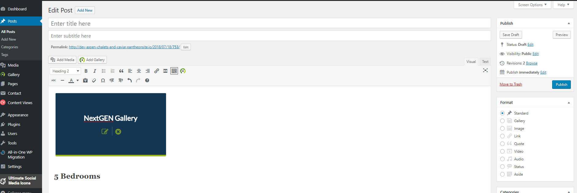

1. To type out another line of detail, i.e.: 5 Bathrooms. Hold down the SHIFT key then press ENTER to make the next line also a “Heading 3” style.

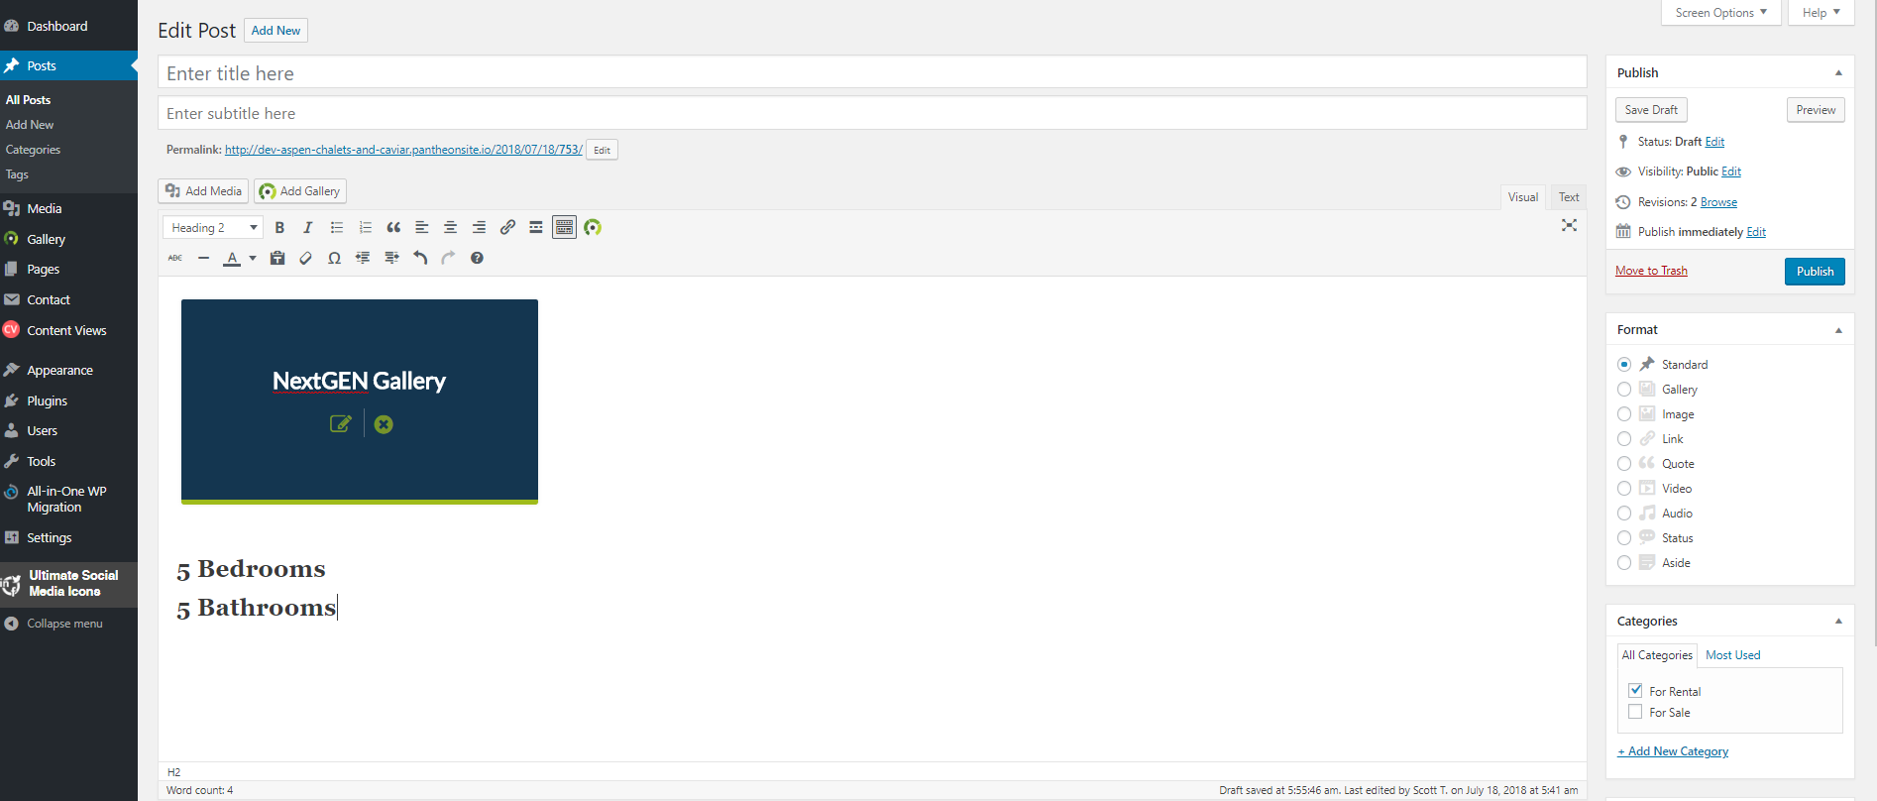

1. Continuing adding lines of major details as necessary.

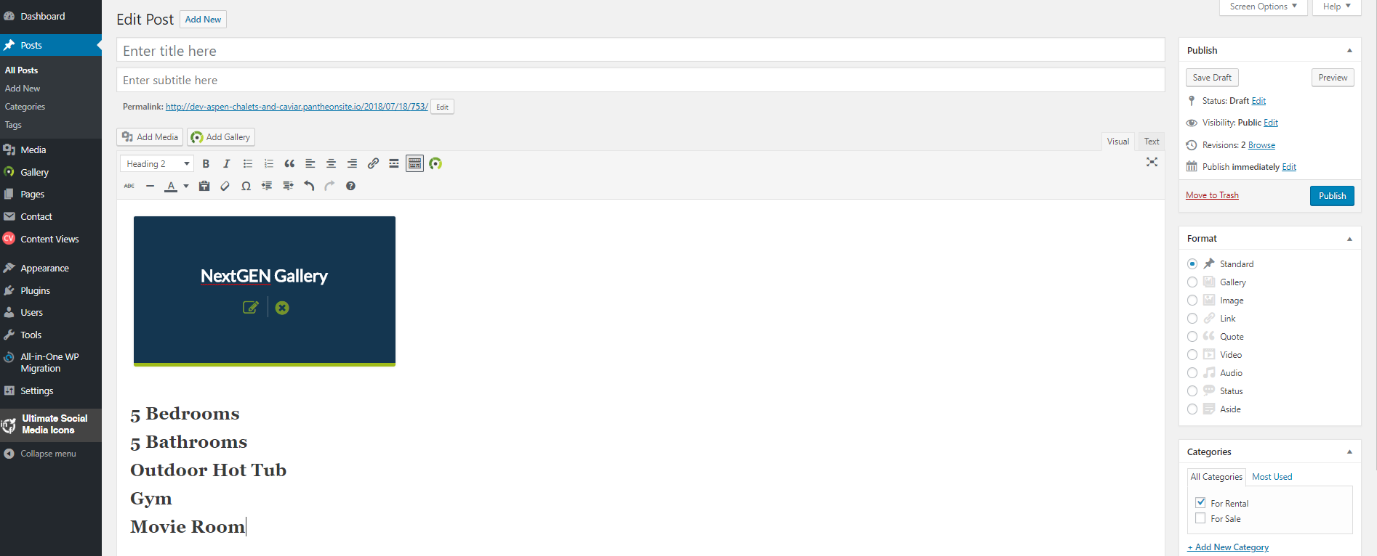

1. After all the major details have been added. You can type a longer summary about the Chalet in the “Paragraph” style.

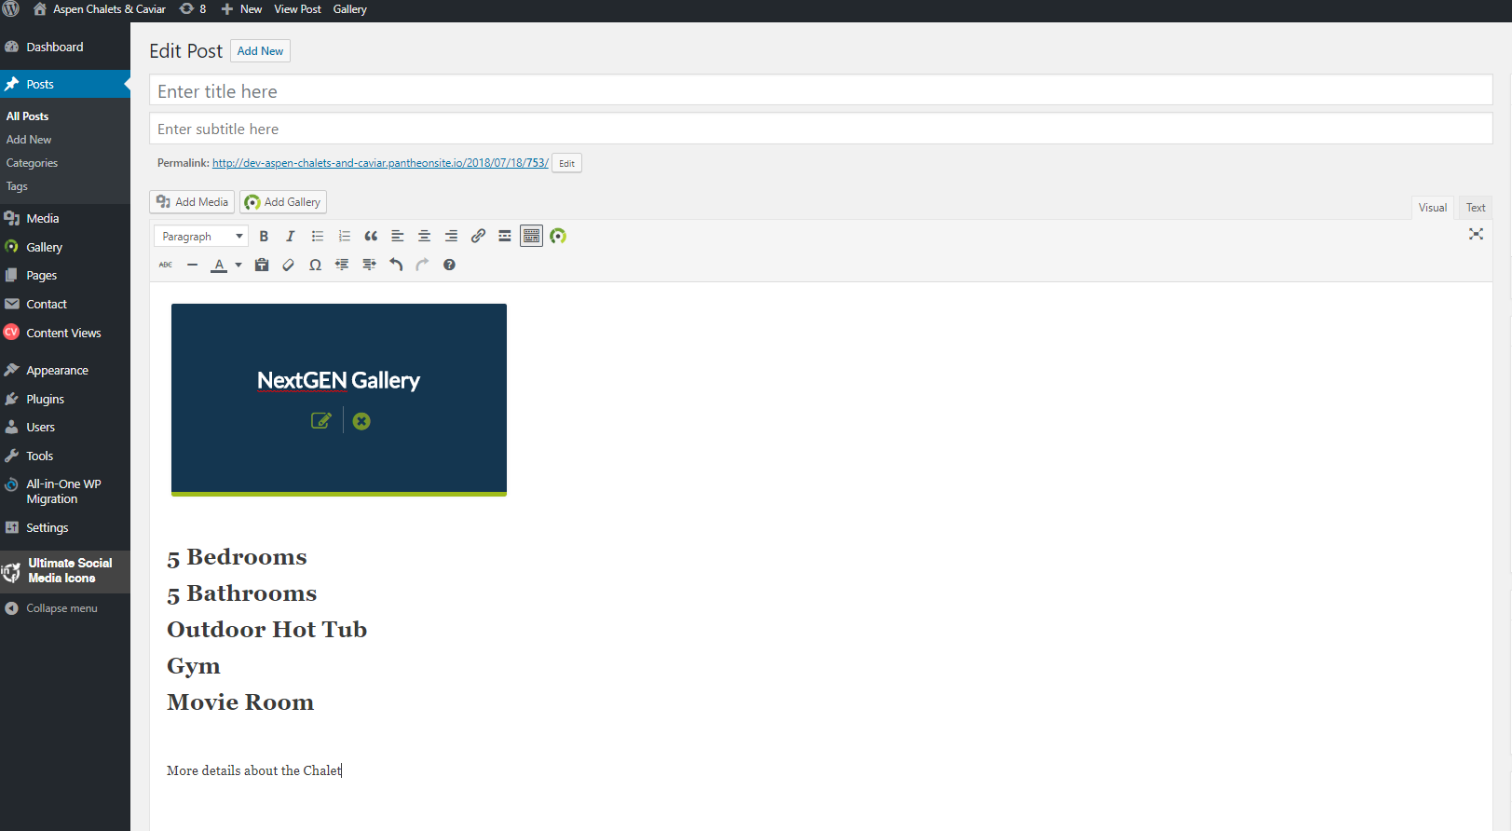

1. To preview your post before publishing it. Click on “Preview Changes” on the top right. This will open a new tab with a preview of your post.

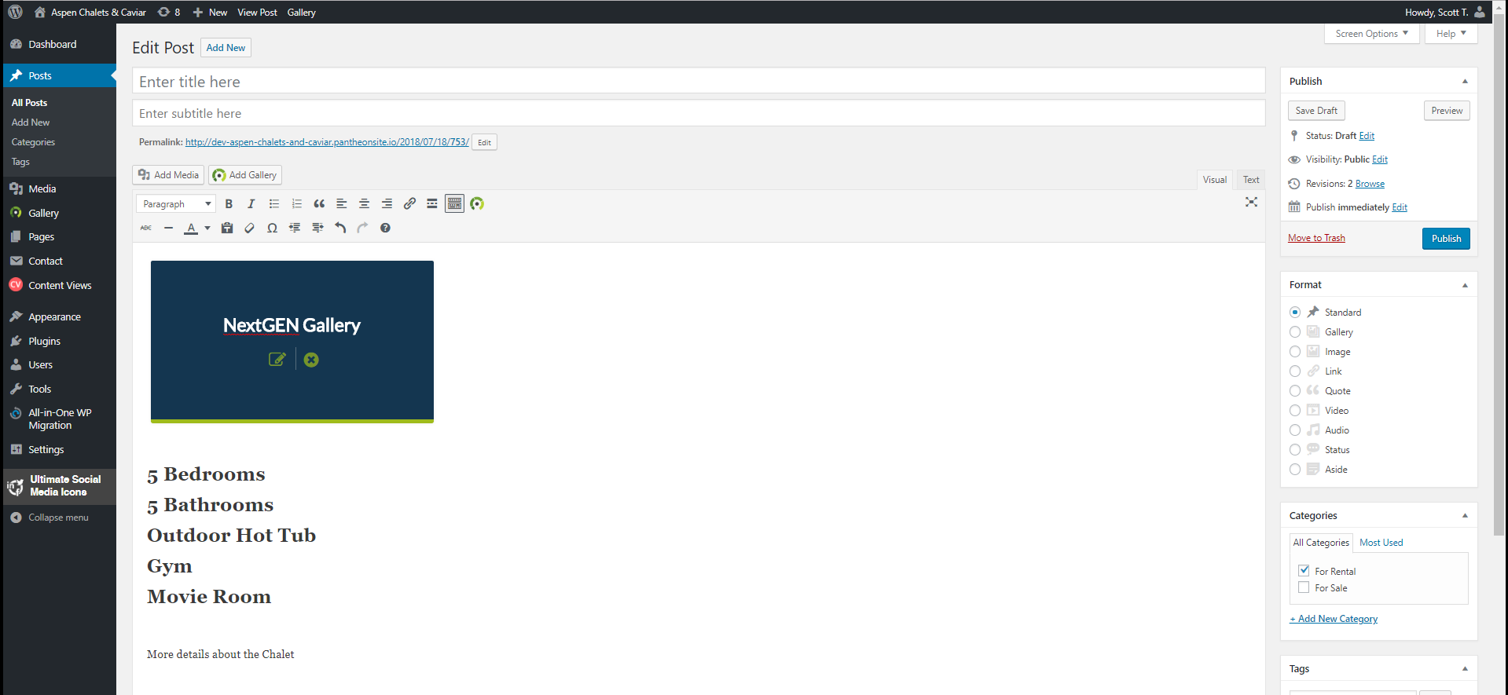

1. When you are satisfied with your post. Click on “Publish” to publish it to the website.



# Edit a Post:

1. At your Dashboard, if you hover your mouse over “Posts” a drop down menu with “All Posts” will appear, click on it.

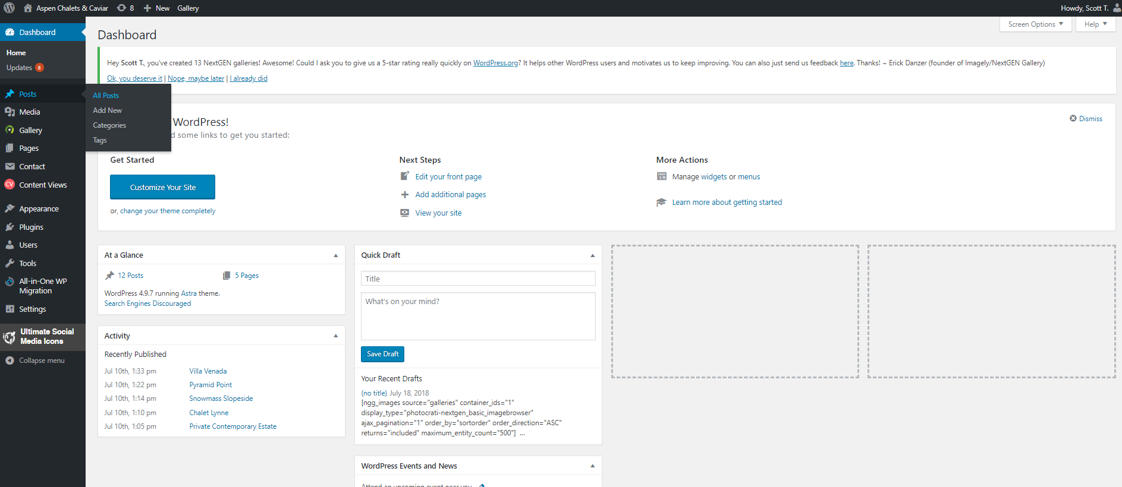

1. Hover your mouse over the post your want to edit. And several options will appear, click on “Edit”

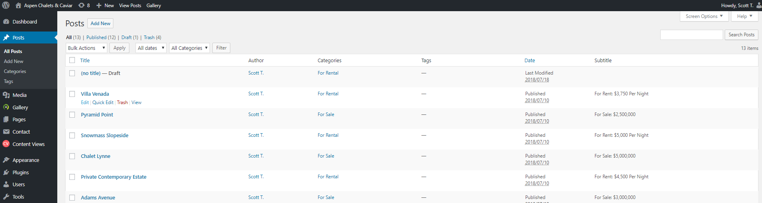

1. This will take you to the Edit Post page of your selected post. From, here you can change what is necessary, preview it, and then publish it.

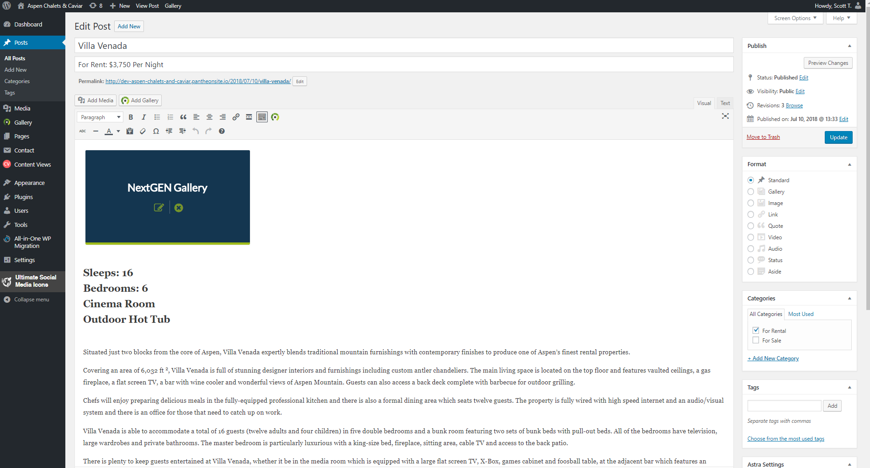

# Delete a Post:

1. At your Dashboard, if you hover your mouse over “Posts” a drop down menu with “All Posts” will appear, click on it.



1. Hover your mouse over the post you want to delete. And several options will appear, click on “Trash”



1. This will send all deleted posts to “Trash” which can be accessed by clicking on “Trash”

